# REGISTER: USER REQUIREMENTS

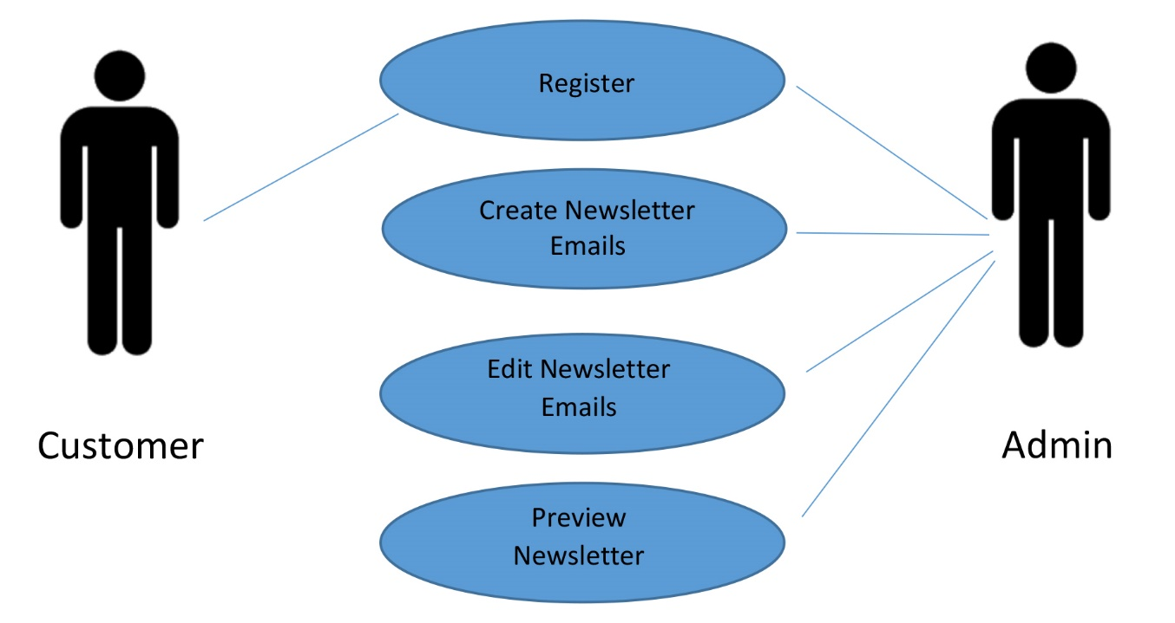

## register

The customer will be asked to register to receive newsletter emails from the website. The customer will be asked to give their first name, last name, and email address. Once the customer puts all the required information for receiving emails the system will validate it. If the information is correct and it is successful, the system will return success and display a message saying, “Thank You”. If the system does not validate the given information the system will be failed and will notify the user. The user will correct the errors and start from the beginning.

The “register” use case contains the following basic steps:

1. The user will submit the required data
2. The system validates it
3. If the validation is successful, the system will return success and display a message saying, “Thank You”
4. If the validation has failed, the system will notify the user and the user will fix the errors and resubmit the required data

## Create newsletter

The admin will create a newsletter and submit it. If the submission was successful the admin will be able to send out emails. Once the admin sends out emails, both the admin and the user will be notified. If the submission has failed, the system will notify the admin, and the admin will fix the errors and resubmit it.

The “create newsletter emails” use case contains the following basic steps:

1. Admin will create Newsletter
2. The admin will submit the newsletter
3. If the submission was successful, the admin will send out emails
4. If the submission has failed, the system will notify the admin, and the admin will fix the errors and resubmit the newsletter.
5. The admin and user will be notified of the submission

## edit newsletter

The admin will be able to go into the Newsletter that they want to edit and make the changes needed. The admin will submit the Newsletter once the changes are made. If the submission was successful, the system will place the original Newsletter with the new Newsletter. The admin will then be able to send out emails to registered users. If the submission failed, the system will notify the admin, the admin will make necessary changes and resubmit the newsletter.

The “edit newsletter” use case contains the following basic steps:

1. Admin will go to the Newsletter that they want to edit, and will make changes to it
2. Admin will submit the Newsletter
3. If the submission was successful, the system will place the original Newsletter with the new Newsletter
4. If the submission has failed, the system will notify the admin, the admin will make appropriate changes and resubmit the Newsletter
5. Once the submission is complete, the admin will send emails to registered users

## PREVIEW NEWSLETTER

The admin will create a Newsletter and submit it. If the submission was successful, the admin will be able to preview the newsletter as a final product. If the submission failed, the system will notify the admin, the admin will make appropriate changes and resubmit the Newsletter. Once the submission is complete, the admin will sent out emails and both the user and admin will be notified.

The “preview newsletter” use case contains the following basic steps:

1. The admin will create the Newsletter
2. Admin will submit the Newsletter
3. If the submission was successful, the admin will be able to preview the final product of Newsletter
4. If the submission failed, the system will notify the admin, admin will make corrections and resubmit the Newsletter
5. Once submission is complete, admin will sent out emails and both user and admin will be notified

# SYSTEM REQUIREMENTS

## register

The following table outlines the details of use case # 1: Register

|  |  |
| --- | --- |
| Use Case ID: 1 | Register |
| Description | The customer will register to receive newsletter from the website. |
| Input | * First Name * Last Name * Email |
| Output | If transaction was successful, then the system will return a Thank You message back to the user. If the transaction failed, the system will notify the user and return the appropriate message. |
| Preconditions | The Email does not exists within the system at the time the user submits the form. |
| Post Conditions | If succeeded, the user will be registered to receive newsletter emails from the website. |
| Frequency of Use | Many times a day |

## Create newsletter

The following table outlines the details of use case # 2: Create Newsletter

|  |  |
| --- | --- |
| Use Case ID: 2 | Create Newsletter Emails |
| Description | The admin will create newsletters that will be sent off to people who are registered to receive newsletter emails. |
| Input | Email |
| Output | If the user has registered to receive emails for newsletters they will be receiving newsletters. |
| Preconditions | The admin must have access to creating newsletter emails as well as be able to see who is registered to receive newsletter emails. |
| Post Conditions | If the email was in the system, the user will receive emails from the website, if the user was not registered they will not receive emails. |
| Frequency of Use | Based on the admin, how many newsletter emails they send out. |

## EDIT NEWSLETTER

The following table outlines the details of use case # 3: Edit Newsletter

|  |  |
| --- | --- |
| Use Case ID: 3 | Edit Newsletter |
| Description | The admin will go to the newsletter email and make the changes needed. |
| Input | * First Name * Last Name * Email |
| Output | If the change was successful the admin will be notified. If the system fails, the admin will be notified to make changes, thereafter will be able to resend the emails to each register user. |
| Preconditions | The admin must has access to editing newsletter emails. |
| Post Conditions | If succeeded, the users who are registered will receive the edited version of the newsletter. |
| Frequency of Use | Based on the admin, how many newsletter emails they send out. |

## PREVIEW NEWSLETTER

The following table outlines the details of use case # 4: Preview Newsletter

|  |  |
| --- | --- |
| Use Case ID: 4 | Preview Newsletter |
| Description | The admin will create newsletter emails to send to people who are registered to receive them. Before the admin sends the emails out to the users, the admin will be able to preview the final product. |
| Input | * Email |
| Output | If the admin submits the newsletter correctly, the admin will be able to view the final product before sending out the emails. |
| Preconditions | The Admin must have access to creating and previewing newsletter emails. |
| Post Conditions | If succeeded, the admin will be able to view the final product of the newsletter before sending it out to registered users. |
| Frequency of Use | Based on the admin, how may newsletter emails they send out. |

# SYSTEM MODELS

## rEGISTER

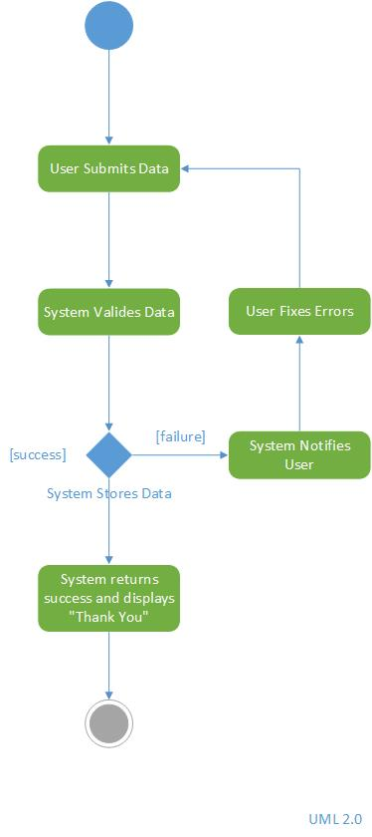

This diagram describes the process that takes place in the registration process. The user will submit the required information that is needed to register in order to receive Newsletters. The system will validate the data.

If the data is successful, the system will return success, and display a message saying “Thank You”.

If the data fails, the system will notify the user, and the user will fix the required errors. Once the user fixes the errors, they will be able to resubmit the registration process.

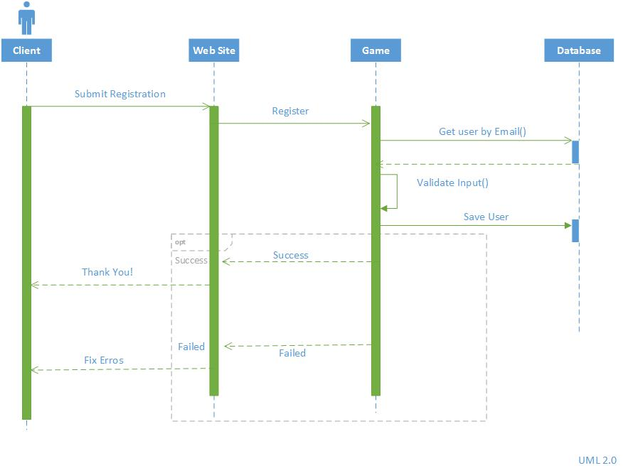

## create newsletter

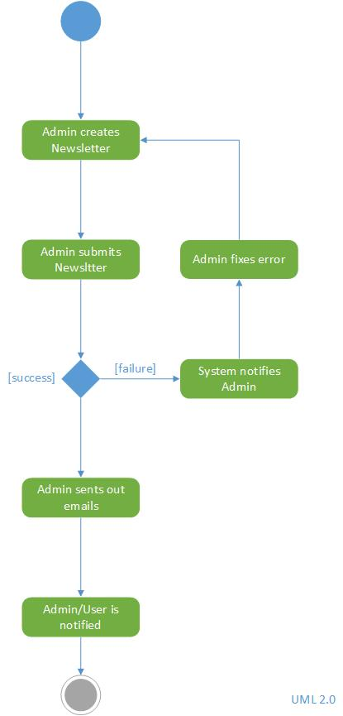

This diagram describes the process that takes place in creating the Newsletter. The admin will create the Newsletter and submit the Newsletter upon completion.

If the submission is successful, the admin will be able to send out emails.

If the submission fails, the system will notify the admin, and the admin will fix the required errors. Upon completion, the admin will resubmit the Newsletter.

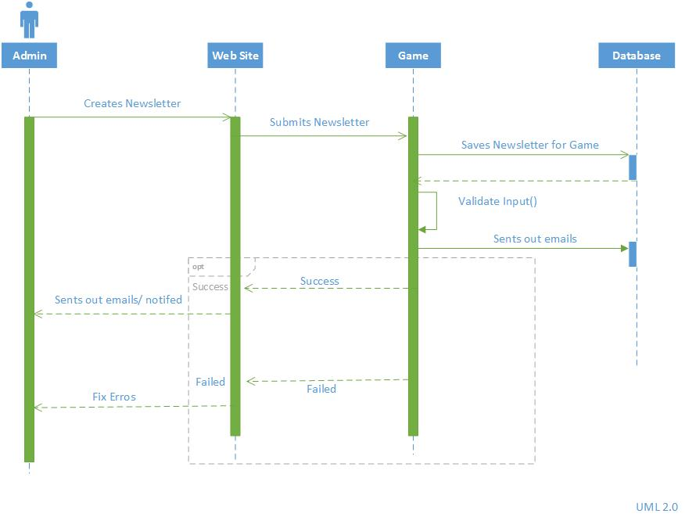

## edit newsletter

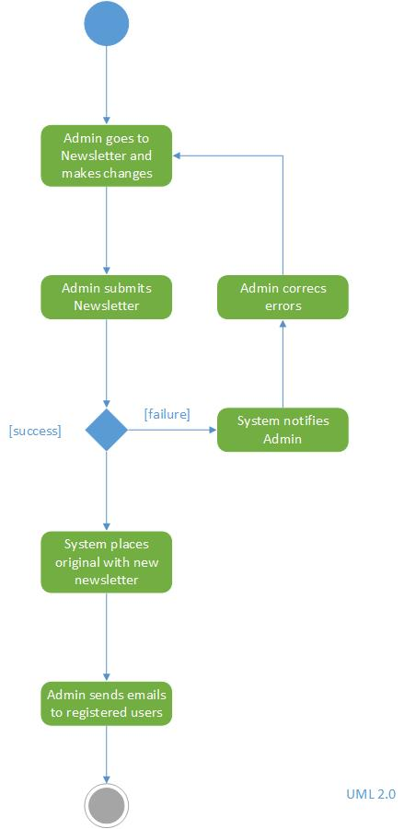

This diagram describes the process that takes place in editing the newsletter. The admin will go to the desired newsletter and make the changes needed. The admin will then submit the Newsletter.

If the submission is successful, the system will place the original Newsletter with the new Newsletter. Thereafter, the admin will send out emails to registered users.

If the submission fails, the system will notify the admin, and the admin will correct the errors. Upon completion, the admin will be able to resubmit the new Newsletter.

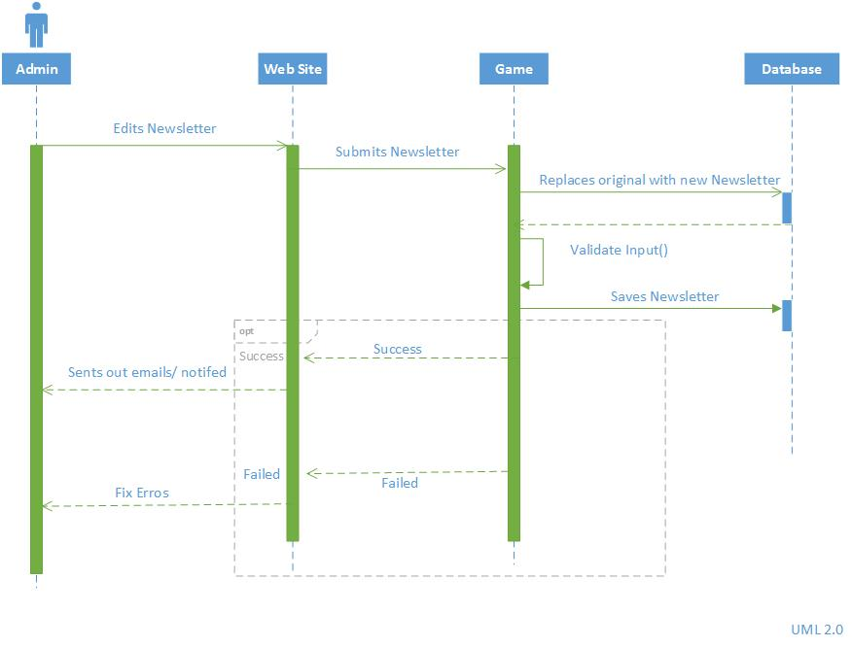

## PREVIEW NEWSLETTER

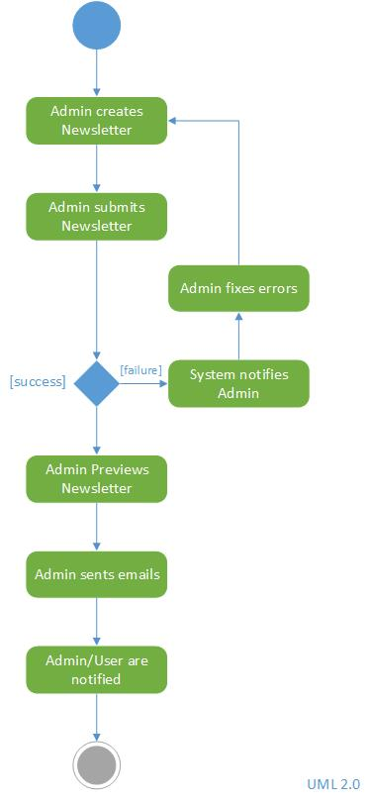

This diagram describes the process that takes place in previewing the Newsletter. The admin will create a Newsletter and submit it.

If the submission is successful, the admin will have the opportunity to preview the Newsletter before sending out emails to registered users.

If the submission fails, the system will notify the admin. The admin will fix the errors, and resubmit the Newsletter again.

